Playability analysing user experience in video games

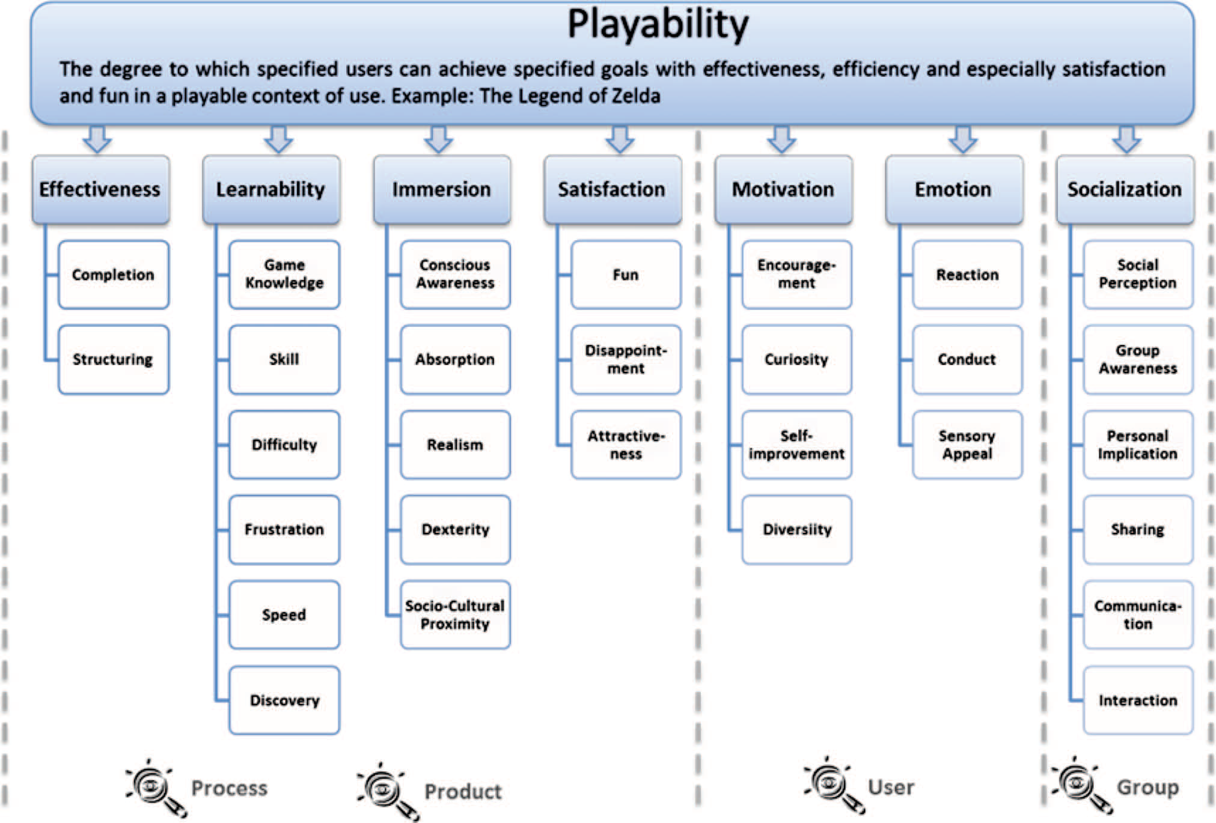
Playability is a term used in the design and analysis of video games that describes the quality of a video game in terms of its rules, mechanics, goals and design. It refers to all the experiences that a player may feel when interacting with a game system. Sometimes, the experience is related with the different ways of interaction among players (Voida and Greenberg 2011).

The work established four principles to consider within the proposed guidelines:
. Intuitive User Interface (emphasising ease of use).
. Played without manual (the players should not feel confused about what to do and how to do it).
. Interfaces that help overcome the traditional learning curve (producing excitement to the player helped by the device or game controller).
. Reality: we should bear in mind that the player is familiar with their environment and the context of life and thus, when designing a video game, we need to provide the user with familiar interaction mechanisms to ensure his or her integration with the virtual world.
Attributes and Properties
To perform the measurement of every attributes and properties of playability it is advisable to take into account the different player profiles1 and video game genres. The meaning or importance of attributes of playability may differ depending on these elements. Figure 1 illustrates the attributes of playability and the properties to identify or measure them. The figure shows whether the attributes and properties are more related, in terms of UX, to the ‘product’ (video games in this work) or to the interaction process and use (player–game interaction), and whether these properties are more influenced by the player’s preferences (player’s vision) or by a group of players (multiplayer games) (Gonza´ lez Sa´ nchez 2011).

We characterise Satisfaction using the following properties:
. Fun: The degree of fun experienced is one of the fundamental properties of player satisfaction.
The main objective of a video game is to entertain; hence a video game that is not fun to
play could never satisfy players. Behaviour & Information Technology 1037
. Disappointment: The degree of Disappointment is a negative property of satisfaction and is linked to, among other things, the player’s personality. We should ensure that players do not feel so disappointed or uneasy while playing a video game that they abandon it altogether.
. Attractiveness: The player’s pleasure and satisfaction with particular aspects of the game that are of interest and gain the confidence of the player.

We propose the following properties to characterize ‘Learn-ability’:
. Game Knowledge: A player’s prior knowledge of a video game will influence the degree to which
they are affected by the learning curve proposed by the game. A habitual player in particular
genres or in previous versions of a game has some experience that naturally means they will
find it easier to assimilate new concepts and understand how to play.
. Skill: Skill is demonstrated by how the player plays. Once they have understood and assimilated
the game’s objectives and rules, how they address the game’s challenges to reach the different objectives and rewards is a matter of skill. A highly skilled player will find it easier to learn the game’s system, because they possess sufficient ability to overcome challenges and to develop their skills further during play.
We distinguish two types of Skill:
. Interactive Skill: The ability to interact effectively with the controls and carry out specific actions or special movements that represent specific events in the virtual game world.
. Cognitive Skill: The ability to understand, assimilate, remember and use different game
concepts or information.
. Difficulty: The degree of difficulty in a video game is a key factor in the learning process, because it encourages players to assimilate and master the game’s dynamics to achieve various goals. Difficulty may be higher or lower depending on how steep the learning curve is, relative to the player’s skills and how long they have been playing. A high Difficulty level can provoke a greater effort by the player to learn how to play.
. Frustration: This property is often part of the learning process and is produced by the player’s
feelings of unease when they are unable to achieve a particular challenge or objective, or
when failing to understand certain concepts. If the player feels too frustrated, this can directly
reduce Playability.
. Speed: The speed with which new concepts and contents are introduced into the game directly affects the learning process. A high level of Speed can prompt the player to exert a high level of effort in the learning process. A low Speed can provoke boredom, which can have a negative effect on Playability.
. Discovery: The degree of Discovery of new contents (rules, rewards, goals, and so on) is a
key factor that helps reduce the effort required in the learning process. Some video games guide or
reveal to the player how to play, using tutorials, different training levels or step-by-step actions
using events (QTE Events2). The different resources for enabling Discovery support better assimilation of the game’s various contents so that the player needs successively less time to improve his abilities to achieve the game’s objectives.

We propose the following properties to characterize Effectiveness:
Completion: Due to the different users’ profiles, the degree of completion may affect to the final experience. For ‘experienced players’ who love to achieve optional challenges or trophies, a video game is more effective if the percentage of Completion is high. In other words, where a video game is played near to 100% across all game scenarios, it can be considered effective in that the player found no parts of the game uninteresting improving the final experience. However, other player profiles (i.e. casuals) have a complete experience with the main challenges of the game and they are not interesting in secondary challenges, goals and items. Completion is principally reflected in the number of optional elements achieved in a game, but it should be measured according to the different players profiles.
. Structuring: The structuring of the game elements (that is, where, when and how they appear in the Gameplay) is a further property of Effectiveness. A video game is well structured when it achieves a good balance between the various objectives to be achieved and the different challenges to overcome, such that the players remain engaged and enjoy themselves throughout the entire game time. The degree in which the game is structured helps to develop the effectiveness of the Gameplay (i.e. number of challenges per level, or number of challenges per time). In addition, this property offers information to re-adapt the experience of the Gameplay to different player profiles (i.e. adding new challenges for expert players).
We propose the following properties to characterize Immersion:
Conscious Awareness: The degree to which the player is consciously aware of the consequences Behaviour & Information Technology 1039 of their actions in the virtual world is one of the fundamental properties of Immersion. The player’s conscious awareness of a video game is represented in their mental model for understanding the game’s objectives, goals, challenges, controls, rewards and any factor which may affect Gameplay. Understanding what happens as a result of carrying out a particular action helps the player imagine what to do next and to develop the necessary abilities to overcome challenges.
. Absorption: The degree of absorption of the player in a video game is one of the most recognisable properties of Immersion. A player who is completely absorbed is involved in the Gameplay to such a degree that they focus all their abilities and attention on overcoming the game’s challenges.
. Realism: The level of realism of a video game has a direct influence on its immersion capacity. Realism is not only hyper-realistic graphics and sounds; it means the capacity of the video game contents to be believable for players. The more realistic a video game is, the greater the Immersion of the player we obtain thanks to consistent sceneries, mechanics and rules for Players when players are interacting with them within the virtual game world. These characteristics of the Gameplay help to be believable for players and improve the immersion. Realism helps the player focus on the game’s challenges, rules and objectives.
. Dexterity: This refers to the player’s dexterity in carrying out different movements and actions in the virtual world in which they are immersed. We note two types of dexterity:
. Interactive Dexterity: The player’s ability to interact with the game’s controls and realise different combinations of movement that are translated into specific actions in the virtual world.
. Virtual Dexterity: The ability to realise different movements and necessary actions inside the virtual world. It can be deduced that to achieve optimum player Immersion, interactive movements (using the game controls) need to be as similar as possible to those carried out in the virtual world.
. Socio-Cultural Proximity: Video Games have more or less immersive efficacy depending on the degree of socio-cultural proximity to the player – appropriate to their age or gender, for instance. The metaphors and atmosphere used in the game, even when realistic, can still reduce the Immersion of the player if they do not reflect certain socio-cultural characteristics that the player can identify with. Video Games that are oriented to a specific gender or age of player tend to produce the greatest immersive effect, reflecting as they do the specific cultural characteristics of the target population.

We propose the following properties to characterize Motivation:
Encouragement: The level of confidence felt when facing new game challenges and the possibility of reaching new game objectives affects the degree of player encouragement. A video game must minimise frustration levels in order to improve a player’s Motivation (positive game encouragement). For example, an extremely low reward for a new challenge can potentially increase the player’s sense of frustration and discouragement. Similarly, a poorly designed video game control that makes it almost impossible for a player to carry out necessary actions in the virtual word will cause them to lose interest in the game.
. Curiosity: One of the basic video game techniques for improving player Motivation is to stimulate intrigue in the discovery of new game elements – in other words, curiosity about what will come next. Curiosity can be generated by the inclusion of optional features, objectives and challenges that offer the player the freedom to interact with a greater number of elements.
. Self-improvement: The degree of player or character improvement is a property that characterises player Motivation. Self-improvement occurs when the player or their character develops their ability and skills – be it to overcome specific challenges, or simply because the player enjoys employing a particular skill.
. Diversity: The number of different elements in a game has, we believe, a direct influence on player Motivation. Diversity of game elements makes 1040 J.L. Gonza´lez Sa´nchez et al. the game more attractive to players and reduces the likelihood of monotony. Examples of such elements might include ‘chance and randomness’ systems that make it impossible to resolve challenges through trial and error, or alternative ways to overcome challenges according to personal taste or ability.

We propose the following properties to characterize Emotion:
Reaction: The player reacts to a video game because the system is a source of different stimuli. The player’s initial reaction may then trigger several types of emotion. Four basic types of player reaction can be identified: Internal, this is an automatic reaction, which is generated through the senses (i.e. feeling disgust at the sight of blood); Behavioural, this is stimulated by the player’s actions and the consequences of these whilst interacting with the video game (i.e. spontaneously cheering when solving challenges and obtaining rewards); Cognitive, this is provoked by the thoughts and memories that a player has when playing the game, reflecting either their own life or past experiences of the game; and Social, this refers to the emotions and reactions experienced by players when playing in company that can provoke an entirely new way of experiencing the game compared to when playing alone.
. Conduct: Video Games are behavioral mechanisms in that they can influence the conduct of the player during Game time, by leading them through different emotions thanks to the stimuli they provide. Video Games are ‘emotional vehicles’, which enable the player to remain emotionally engaged for the entire duration of the game and thus improve their interaction with the virtual world.
. Sensory Appeal: Since the game needs to transmit a series of emotions to the player, it needs to use different sensory channels to stimulate the player’s senses. The use of different channels, such as graphics to stimulate the player visually, triggers a cognitive reaction in the player, which enables them to process the game whilst feeling the emotions it induces.

We propose the following properties to characterize Socialisation:

Social Perception: This is the degree of social activity used and understood by players, who experience a more extensive game in a multiplayer context than they do playing on their own. It is important to ensure that players appreciate the difference between the two contexts, so as to increase their social awareness.
. Group Awareness: This refers to the conscious awareness of players of being part of a ‘team’, and of sharing common objectives, challenges and game elements. Players must understand that they are a part of a group and that the success of the group depends on achieving shared objectives. The game should be designed in such a way as to encourage each player to contribute their experience, without undermining other players. Sometimes a player, together with other characters, needs to understand and negotiate group interests according to the game dynamics.
. Personal Implication: The Personal Implication of the individual with the group in the dynamic of the game is a further property of Socialisation. The player needs to be aware that individual achievement leads to group victory. Hence, rules, challenges and objectives need to be developed that help raise the player’s awareness of their role in the group’s success, and their identification with it. Behaviour & Information Technology 1041
. Sharing: Shared game resources, and how they are managed, are key factors in Socialisation in video games. When a player plays within a group, the objectives are shared, but so is the responsibility for working towards them by players and characters. For example, players may exchange information to resolve particular challenges.
. Communication: The extent of communication among group members is one of the defining factors of Socialisation in a game. Multiplayer video games should offer communication mechanisms that enable optimal interchange of information among players. Some of the more popular communication mechanisms include instant messaging, blackboards and video/voice calls, as well as mechanisms which need face-toface communication in front of the game device itself.
. Interaction: How the group perceives the rules of the game or how members will interact to achieve the objectives are crucial properties of Socialisation. The way in which characters or players relate to each other allows objectives and challenges to be overcome in different ways according to the interests fostered by interaction among group members. We highlight the following types of interaction: Competitive, when a player plays to achieve personal success; Collaborative, individual success is replaced by group success; and Cooperative, Players can have their individual goals whilst forming a group to benefit themselves, thanks to the help of other members. The majority of games implement cooperation techniques among players or characters to achieve the most valuable rewards in the game.

Measurement of playability: facets and surfaces of playability
The six Facets of Playability are:
Playability: This is the Playability inherent in the nature of the video game itself and how it is presented to the player. It is closely related to Gameplay design and Game Mechanic. In this facet, for example, we can analyse the game’s rules, goals, objectives, rhythm and other mechanics.
. Mechanical Playability: This is related to the quality of the video game as a software system. It is associated with the Game Engine, with particular emphasis on, for example, the fluency of the film scenes, correct lighting, sound, music, animated graphics and characterisation, as well as communication systems in a multiplayer video game.
. Interactive Playability: This is associated with player interaction and video game user interface development, for example, interaction dialogue and game controls. This aspect of Playability is strongly connected to the Game Interface.
. Artistic Playability: This facet relates to the quality of the artistic and aesthetic rendering in the game elements – visual graphics, sound effects, music and melodies, storyline and storytelling – and how these elements are executed in the video game.
. Intrapersonal Playability or Personal Playability: This refers to the individual outlook, perceptions and feelings that the video game produces in each player when they play, and as such has a high subjective value.
. Interpersonal Playability or Social Playability: This refers to the feelings and perceptions of users, and the group awareness that arise when a game is played in company, be it in a competitive, cooperative or collaborative way.
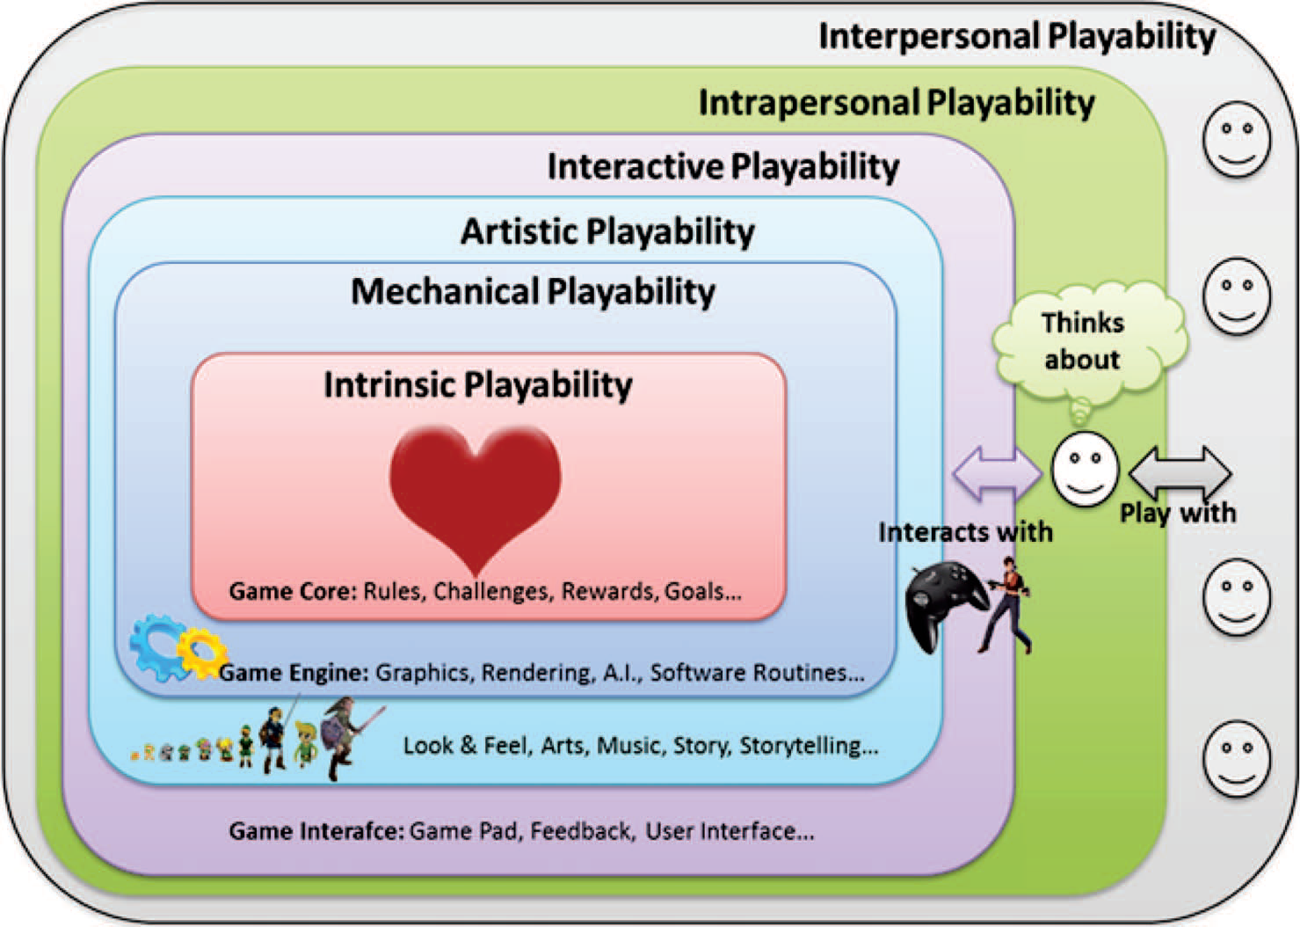


The most significant results about the profile of the participants were as follows (pre-test):
. The majority were male (#80%) between 20 and 25 years old (90%).
. Considered to be casual players (play approximately 5 h per week and have experience of only one games console or a mobile phone).
. Had knowledge of different gaming platforms, including a mobile and a desktop platform (#90%).
. 20% of the students had a ‘higher level’ as players (they are referred to as ‘hardcore’ players), playing more than 5 h per week and with experience of more than one games consolesuch as Ps3 and Wii, laptops and mobile phones. These players acted as video game ‘experts’ in the evaluation process.

Some interesting results about Test process are revealed:
. At the beginning of the adventure, players were uncertain, looking around to capture all screen elements (#78%).
. With the arrival of challenges at the climax of the level, stress increased, provoking surprise and agitation in the player (lifting of the eyebrows, 94%). The stress caused by the challenges increased the player’s concentration. Players pressed the pad quicker and more violently (#89%) than at the beginning of the game.
. At the climax of the level, two types of strategies were detected: a defence strategy, which was adopted by 100% of female users and 25% of men, who were intimidated by the game enemies and natural catastrophes. However, 75% of male users preferred a direct and violent confrontation. In both cases, the degree of immersion was high, a factor which was indicated by the increase of the movement of the game control and how the player presses the buttons with more violence, even when the action was over.
. Finally, stress became satisfaction, which was expressed as a slight smile or slight gasp (#82%).

Following our experiment, the analysis of UX can be summarised in these main points (post-test):
. One of the clearest results was that ‘casual’ players were happiest with the game. This was reflected in the high values scored for the interactive facet, and ease of use of game controller (see Section 3.1.2).
. The positive result for ‘casual’ players meant a negative experience for ‘expert’ players, due to the excessive ease of play. The challenges and goals, which contribute to the learning process, were too simple, decreasing emotion and motivation during the play. This result was corroborated by low degree of ‘personal’ playability in ‘expert’ profiles.
. Concerning the artistic level, the results showed how the game’s graphical quality was acceptable by all players, but the ‘expert’ players preferred the higher graphic quality of other platforms, such as Xbox360 and PS3, and considered the aesthetic aspect of the game to be a little disappointing.
. Most differences in the results can be seen in the social factor. ‘Casual’ players were satisfied by sharing the game with other players, increasing a positive experience that complements the infrequency of social challenges with other characters in the game process. For the ‘expert’ player, the result was a negative social experience, contributing to lower levels of motivation. This was due to the fact that ‘expert players’ normally play video games in an online setting and are accustomed to interacting in much more complex social challenges.
. For both ‘casual’ and ‘expert’ players, the game provided high values of excitement (high degree of emotion) and immersion due to the controls and game dynamics (slightly lower for ‘expert’ player because they are used to playing these kinds of games on a more frequent basis).
. The effectiveness of the game was high, the players had fun, but it is difficult to extrapolate global results due to the limited number of sessions. An increased number of sessions may have given different results. However, expert players achieved more challengers and explored in deep the different options of the Gameplaymechanics/dynamics (see Table 4).
. It can clearly be seen that the game should provide different difficulty levels for the expert player. More complex challenges could thus improve the motivation attribute.
. In both player profiles, the most valued video game element is the game platform. This result was obtained thanks to the integrity rules and structural equations of the conceptual model used in PHET (Gonza´ lez Sa´nchez 2011), where each element of the game can be analysed, evaluating its impact

